|  |  |  |  |  |  |  |  |  |
| --- | --- | --- | --- | --- | --- | --- | --- | --- |
|  | BX | AL | CH | CL | ZF | CF |  | memory |
| Mov BX,2000H | 2000H |  |  |  |  |  | 2000H | F0H |
| Mov AL, [BX] |  | F0H |  |  |  |  | 2001H | 30H |
| INC BX | 2001H |  |  |  | 0 |  |  |  |
| ADD AL, [BX] |  | 20H |  |  | 0 | 1 |  |  |
| Mov CL,17H |  |  |  | 17H |  |  |  |  |
| SUB AL, CL |  | 9H |  |  | 0 | 0 |  |  |
| Mov CH,0 |  |  | 0H |  |  |  |  |  |
| ADD BX, CX | 2018H |  |  |  | 0 | 0 |  |  |
| SUB CH, AL |  |  | F7H |  | 0 | 1 |  |  |
|  |  |  |  |  |  |  |  |  |

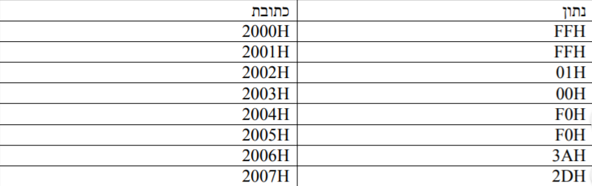MOV AX,8000H

MOV BX,8000H

ADD AX, BX

MOV SI,2000H

MOV AX, [SI]

INC SI

ADD AX, [SI]

INC SI

ADD AX, [SI]

INC SI

ADD [SI], AL

|  |  |  |  |  |
| --- | --- | --- | --- | --- |
| AX | BX | SI | ZF | CF |
| 8000H |  |  |  |  |
|  | 8000H |  |  |  |
| 0000H |  |  | 1 | 1 |
|  |  | 2000H |  |  |
| FFFFH |  |  | 0 | 0 |
|  |  | 2001H | 0 | 0 |
| FF00H |  |  | 0 | 1 |
|  |  | 2002H | 0 | 0 |
| 0000H |  |  | 1 | 1 |
|  |  | 2003H | 0 | 0 |
| 00H | F0H |  | 0 | 0 |
|  |  | 2004H | 0 | 0 |
|  |  | 2004H | 0 | 0 |

MOV BX,2000H

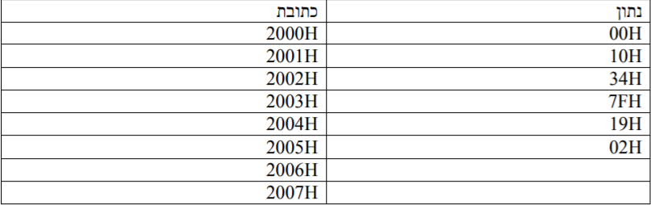MOV AX,0

ADD AX,[BX]

ADD BX,2

ADD AX,[BX]

ADD BX,2

ADD AX,[BX]

ADD BX,2

MOV [BX],AX

|  |  |  |  |  |
| --- | --- | --- | --- | --- |
| BX | AH | AL | ZF | CF |
| 2000H |  |  |  |  |
|  | 00H | 00H |  |  |
|  | 00H | 00H | 1 | 0 |
| 2002H |  |  | 0 | 0 |
|  | 00H | 34H | 0 | 0 |
| 2004H |  |  | 0 | 0 |
|  | 00H | 4DH | 0 | 0 |
| 2006H |  |  | 0 | 0 |
| 2006H |  |  |  |  |
|  |  |  |  |  |

14.11.18

כתוב תוכנית שבודקת האם הנתון שנמצא בכתובת 1000H בזיכרון שווה לנתון שנמצא בכתובת 1001H בזיכרון.

אם כן, יש להעביר לכתובת 1002H בזיכרון את הערך 20H.

אחרת, יש להעביר לכתובת יש להעביר לאותה הכתובת את הערך 25H

Mov DI,1000H mov BX,1000H

Mov SI,1001H mov AL,[BX]

mov AL,[DI] INC BX

mov BL,[SI] SUB AL,[BX]

Mov SI,1002H JZ XYZ

SUB AL,BL mov AL,25H

JZ XYZ INC BX

mov AL,25H mov [BX],AL

mov [SI],AL JMP sof

JMP Sof

XYZ: mov AL,20H

mov AL,20H INC BX

mov [SI],AL mov [BX],AL

Sof: